Date: Oct 23, 2025
To: Weber County Board of County Commissioners
From: Ronna Tidwell
Community Development Department
Agenda Date: Oct 28, 2025
Subject: Request to Declare Parcel Number 15-059-0005 as Surplus Property
Attachments: A - Aerial Vicinity Map
B - Ownership Plat

_____________________________________________________________________________________

Summary:

A Weber County owned parcel of land, identified as Tax ID #15-059-0005, was acquired by the County through a tax sale process and deed executed in 1945. The parcel contains approximately .64 acres and is located approximately 3950 West 1200 South, in Ogden. See Attachment A for a vicinity map and Attachment B for the County Recorder’s ownership plat map.
The County was approached by an adjacent property owner with interest in purchasing the subject parcel.
Weber County has no intended use for this property; therefore, it is recommended by the County Commissioner’s that the parcel be declared as surplus and offered to all the adjacent property owner’s of interest, in which they will all be notified via mailed notification letters of availability. To convey real property, the County Commission must first take action to declare this parcel as surplus property.

Property Description:

15-059-0005

PART OF NORTHWEST QUARTER SECTION 21, TOWNSHIP 6 NORTH, RANGE 2 WEST, SALT LAKE MERIDIAN, U.S. SURVEY: BEGINNING 33.5 RODS WEST OF SOUTHEAST CORNER OF NORTHEAST QUARTER OF NORTHWEST QUARTER OF SAID SECTION; THENCE NORTH 5.88 CHAINS; THENCE WEST 108.92 FEET; THENCE SOUTH 8.5 RODS; THENCE EAST 4 RODS 6 FEET; THENCE SOUTH TO POINT WEST OF BEGINNING; THENCE EAST TO BEGINNING.

Attachment A
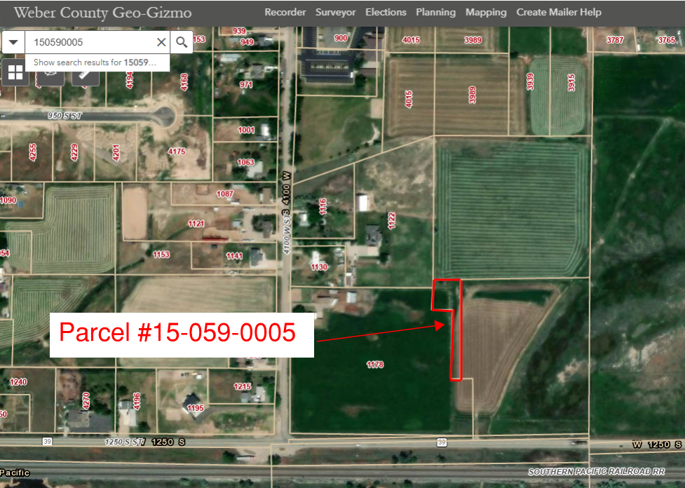

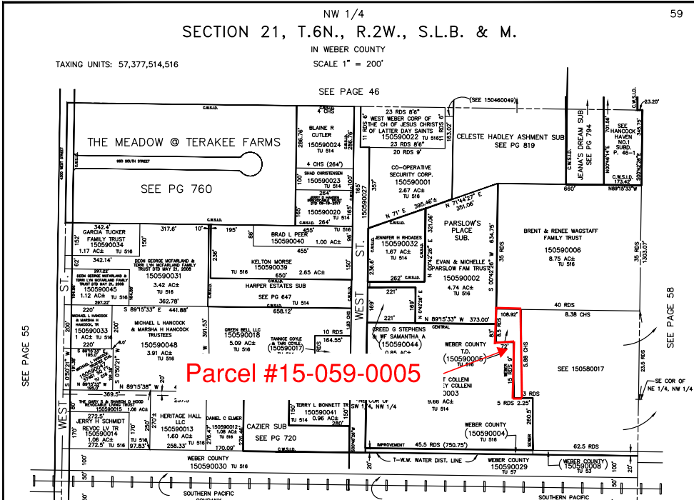
Attachment B

